**How to Insert a Page Number in the HTML Footer Using the Inline Style**

The Syncfusion® HTML to PDF converter is a .NET library for converting webpages, SVG, MHTML, and [**HTML to PDF using C#**](https://www.syncfusion.com/document-processing/pdf-framework/net/html-to-pdf). It is reliable and accurate. The result preserves all graphics, images, texts, fonts, and the layout of the original HTML document or webpage.

Using this library, you can insert a page number in the HTML footer using the inline style.

**Steps to insert a page number in the HTML footer using the inline style to PDF document**

1. Create a new C# console application project.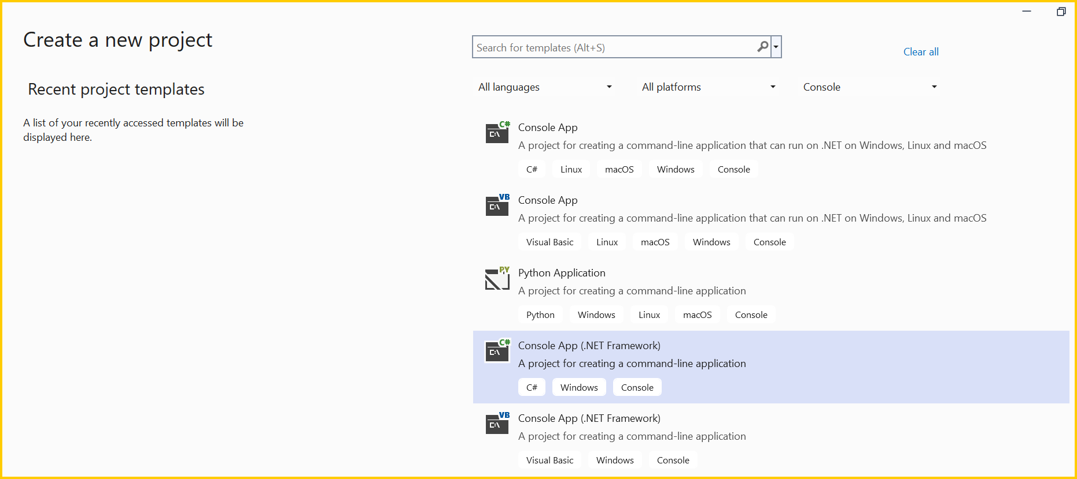A screenshot of a computer

   AI-generated content may be incorrect.
2. Install the **[Syncfusion.HtmlToPdfConverter.WinForms](https://www.nuget.org/packages/Syncfusion.HtmlToPdfConverter.WinForms" \t "_blank)** NuGet package as a reference to your .NET Framework application from [**NuGet.org**](http://nuget.org/).

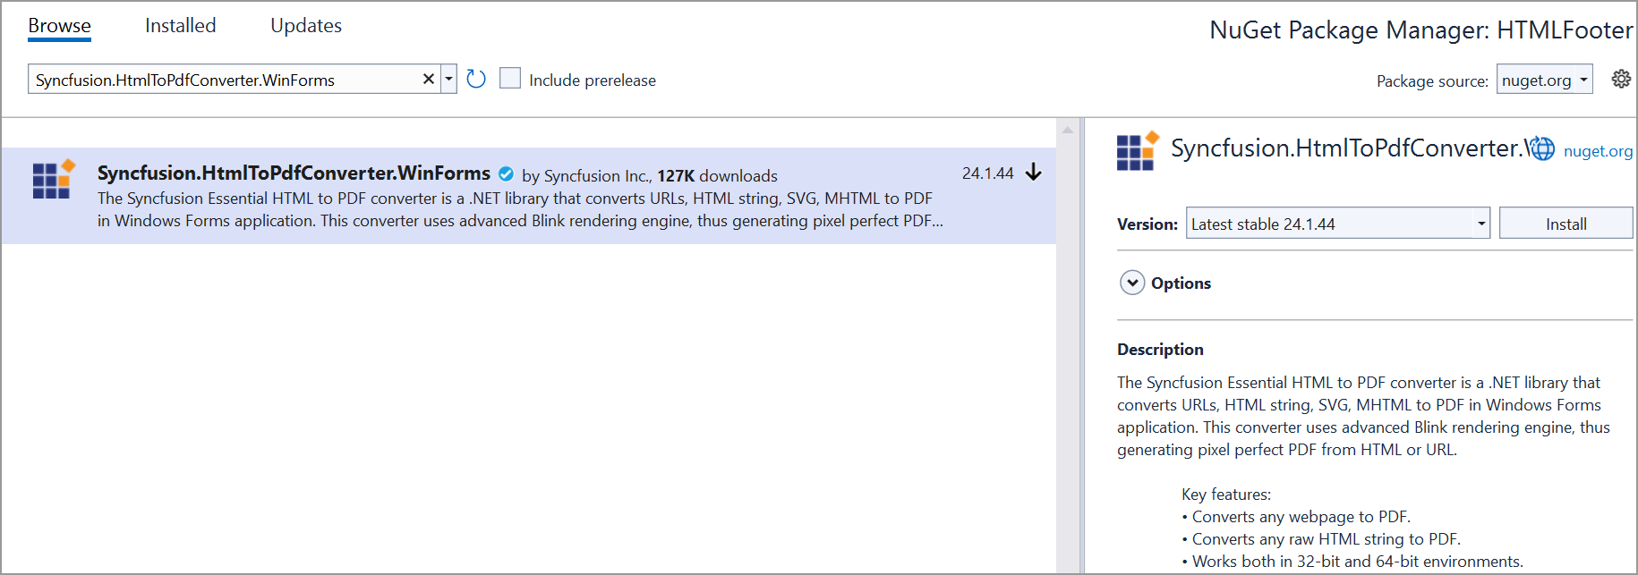

1. Include the following namespaces in the Program.cs file.

C#

using **Syncfusion**.HtmlConverter;

using **Syncfusion**.Pdf;

using **System**.Drawing;

using **System**.IO;

[**VB.NET**](http://vb.net/)

**Imports** **Syncfusion**.HtmlConverter

**Imports** **Syncfusion**.Pdf

**Imports** **System**.Drawing

**Imports** **System**.IO

1. Use the following code sample to insert a page number in the HTML Footer in a PDF file.

C#

//Initialize HTML to PDF converter.

**HtmlToPdfConverter** htmlConverter = **new** **HtmlToPdfConverter**();

//Initialize blink converter settings.

**BlinkConverterSettings** blinkConverterSettings = **new** **BlinkConverterSettings**();

//Set the Blink viewport size.

blinkConverterSettings.ViewPortSize = **new** **Size**(800, 0);

//Set the HTML margin-top value based on the HTML header height and margin-top value.

blinkConverterSettings.Margin.Top = 70;

/**Set** the HTML margin-bottom value based on the HTML footer height and margin-bottom. value.

blinkConverterSettings.Margin.Bottom = 40;

//Set the custom HTML header to add at the top of each page.

blinkConverterSettings.HtmlHeader = "<span style=\"font-size: 13px; font-weight: bold; text-align: center; margin-left: 300px; \">HTML to PDF Converter</span></span>";

//Set the custom HTML footer to add at the bottom of each page.

blinkConverterSettings.HtmlFooter = "<span style=\"font-size: 8px; margin-left: 340px;\">Page <span class=\"pageNumber\"></span> of <span class=\"totalPages\"></span></span>";

//Assign Blink converter settings to the HTML converter.

htmlConverter.ConverterSettings = blinkConverterSettings;

//Convert the URL to a PDF document.

**PdfDocument** document = htmlConverter.**Convert**(**Path**.**GetFullPath**("../../../Data/HtmlSample.html"));

//Create a file stream.

**FileStream** fileStream = **new** **FileStream**("Output.pdf", **FileMode**.Create, **FileAccess**.ReadWrite);

//Save and close a PDF document.

document.**Save**(fileStream);

document.**Close**(true);

[**VB.NET**](http://vb.net/)

'Initialize HTML to PDF converter.

Dim htmlConverter As New HtmlToPdfConverter()

'**Initialize** blink converter settings.

**Dim** blinkConverterSettings **As** **New** **BlinkConverterSettings**()

'Set the Blink viewport size.

blinkConverterSettings.ViewPortSize = New Size(800, 0)

'**Set** the HTML margin-top value based on the HTML header height and margin-top value.

blinkConverterSettings.Margin.Top = 70

'Set the HTML margin-bottom value based on the HTML footer height and margin-bottom value.

blinkConverterSettings.Margin.Bottom = 40

'**Set** the custom HTML header to add at the top **of** each page.

blinkConverterSettings.HtmlHeader = "<span style=""font-size: 13px; font-weight: bold; text-align: center; margin-left: 300px;"">HTML to PDF Converter</span>"

'Set the custom HTML footer to add at the bottom of each page.

blinkConverterSettings.HtmlFooter = "<span style=""font-size: 8px; margin-left: 340px;"">Page <span class=""pageNumber""></span> of <span class=""totalPages""></span></span>"

'**Assign** **Blink** converter settings to the HTML converter.

htmlConverter.ConverterSettings = blinkConverterSettings

'Convert the URL to a PDF document.

Dim document As PdfDocument = htmlConverter.Convert(Path.GetFullPath("../../../Data/HtmlSample.html"))

'**Create** a file stream.

**Dim** fileStream **As** **New** **FileStream**("Output.pdf", **FileMode**.Create, **FileAccess**.ReadWrite)

'Save and close a PDF document.

document.Save(fileStream)

document.Close(True)

Download the work sample from [**HTMLFooter.zip**](https://www.syncfusion.com/downloads/support/directtrac/general/ze/HTMLFooter291234612).

By executing the program, you will get a PDF document as follows.

Take a moment to peruse the [**documentation**](https://help.syncfusion.com/file-formats/pdf/converting-html-to-pdf), where you can find converting HTML pages to PDF document along with respective customization options and features.

Refer [**here**](https://www.syncfusion.com/document-processing/pdf-framework/net/html-to-pdf) to explore the rich set of Syncfusion Essential® PDF features.

Note:Starting with v16.2.0.x, if you reference Syncfusion® assemblies from trial setup or from the NuGet feed, include a license key in your projects. Refer to this [**link**](https://help.syncfusion.com/common/essential-studio/licensing/overview) to learn about generating and registering Syncfusion® license key in your application to use the components without trail message.